### NEW A126 Dis-Eur-Czech Republic-Moravia-Střelice-Figurine-Female-Venus-Ceramic

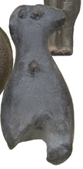

Fig. 1. Czech Republic-Moravia-Střelice-Figurine-Female-Venus-Ceramic

### ****Formal Label:**** Czech Republic-Moravia-Střelice- Figurine-Female-Venus-Ceramic

**Display Description:** Střelice Moravian ceramic figurines, such as this one, were located in the context of habitations (notably near hearths, see Sázelová 2008) in settled areas in large reoccupied sites near agricultural resources (Čižmář et alii 2008), which near this site is still being farmed today. A very conservative figural grammar (Humpolová and Podborský 2013) was evidently sustained for many generations based on C14 data (Kuča 2012, 2011). This figure has been fractured, probably in antiquity: the head, right arm and both legs are missing. This figure also has an everted umbilical cord residuum (belly button). A trademark of a real pregnancy is an everted umbilical cord residuum.

### ****Accession Number**:** A126

### LC Classification: GN772

**Date or Time Horizon:** 4,850 BCE-4,450 BCE

**Geographical Area:** Czech Republic, Moravia,Střelice

**Map, GPS Coordinates:** 48.89567 16.13701, 40° 26' 46" N 79° 58' 56" W

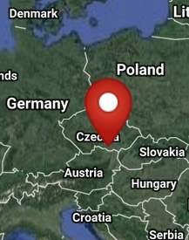 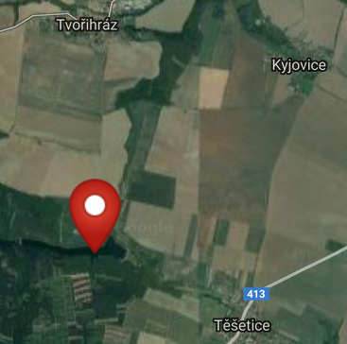

Fig. 2-3. Map of location of Sutnach site at Těšetice-Kyjovice from http://latitude.to/img/latitude-logo.svg.

**Cultural Affiliation:** Neolithic

**Medium:** Fired clay.

**Dimensions:**

**Weight:**

**Condition: Resin replica of original.**

**Provenance:** Czech Republic, Moravia,Střelice Museum.

**Discussion:**

The emphasis on small breasts and a large pelvis suggest that this figurine is associated with a general social and health anxiety for safe childbirth, especially in an age when women were expected to have many children. Figurines incorporating indications of these anxieties may have accompanied the instructions (perhaps incorporated in rituals) by women midwives who had expertise in the care of pregnant mothers and the practice and art of delivering babies safely.In Neolithic communities it is important to have many children as the farm-work required many hands. Midwives still perform the same tasks to assist their communal sisters in pregnancy and childbirth. Indeed, a similar anxiety to have many children is noticeable today among traditional farming families in many parts of the world, especially in Africa, India, and South America.

**References:**

Čižmář, Zdeněk, ed*.* 2008. *Život a smrt v mladší době kamenné. Katalog výstavy. Leben und Tod in der Jungsteinzeit.* [Life and Death in the New Stone Age.] Brno:Ústav archeologické památkové péče ve spolupráci s Jihomoravskzm muzeem ve Znojmě a Moravským zemským muzeem v Brně.

Humpolová, Alena and Vladimír Podborský. 2013. *To nejlepší z archeologické sbírky Františka Vildomce.* [The Best of the Archaeological Collection of František Vildomec]. Brno: Moravské zemské muzeum.

Králík, Miroslav and Novotný, Vladimír. 2005. Dermatoglyphics of Ancient Ceramics. In: Svoboda Jiří, ed. *Pavlov I Southeast. A Window into the Gravettian Lifestyles*. Brno: Academy of Sciences of the Czech Republic, Institute of Archaeology, and Kraków: Polish Academy of Sciences, Institute of Systematics and Evolution of Animals, Chapter IV.5, pp. 449-430.

Kuča, Martin, Jan Josef Kovář, Miriam Nývltová Fišáková, Petr Škrdla, Lubomír Prokeš, Miroslav Vaškových, and Zdeněk Schenk. Chronologie neolitu na Moravě. Předběžné výsledky. 2012. [Chronology of the Moravian Neolithic. Preliminary results.] Přehled výzkumů, 53(1).

Kuča, Martin, Jan Josef Kovář, Miriam Nývltová Fišáková, Petr Škrdla, Lubomír Prokeš, Miroslav Vaškových, and Zdeněk Schenk. 2011. Chronologie neolitu na Moravě: Předběžné výsledky,” *Přehled výzkumů*, 53(1).

Sázelová, Sandra. 2008. “Female Figurines of Northern Eurasia: An Ethnological Approach.” In Svoboda, Jiří A., *Petřkovice. On Shouldered Points and Female Figurines.* The Dolní Věstonice Studies, Vol. 15, Brno: Academy of Sciences of the Czech Republic, Institute of Archaeology, pp. 224-232.

Svoboda, Jiri, Vojen Lozek, and Emanuel Vlcek. 1996. *Hunters between East and West, the Paleolithic of Moravia*. New York: Plenum Press; New York: Springer.